Radium Sorption to Iron (hydr)oxides, Pyrite, and Montmorillonite: Implications for Mobility

Michael A. Chen and Benjamin D. Kocar*

Dept of Civil and Environmental Engineering,

Massachusetts Institute of Technology

*Corresponding author, kocar@mit.edu

**Abstract**

Radium (Ra) is a radioactive element commonly found within soils, sediments and natural waters. Elevated Ra activities arising through natural and anthropogenic processes pose a threat to groundwater resources and human health, and Ra isotope ratios are used to decipher groundwater movement, estimate submarine discharge flux, and fingerprint contamination associated with hydraulic fracturing operations. Although adsorption to mineral surfaces, particularly by metal (hydr)oxides, is well established as a dominant mechanism controlling Ra transport and retention, there is limited understanding of how Ra associates with other mineral surfaces. Here, we present results of sorption studies and surface complexation modeling (SCM) of Ra to ferrihydrite, goethite, montmorillonite, and pyrite, for a range of pH values and common background cations. We find that while all minerals show some amount of sorption over the geochemical conditions considered, each mineral shows different sensitivity to solution pH and specific competing cations. Literature defined SCMs were fitted to experimental data to match either the impact of pH or different cation(s), but those fits produced by these two methods were mismatched, suggesting that these laboratory tuned constants for these models will not easily predict the transport of Ra in natural environments. Ultimately, we have demonstrated the sensitivity of Ra sorption to key geochemical parameters and mineralogy, suggesting that typical means of accounting for Ra transport (ie Kd) may not be sufficient to explain spatio-temporal variations of Ra in the environment.

**Table of Contents (TOC) /Abstract Art**

**Introduction**

Chronic ingestion and inhalation of radioactive materials, including radium (Ra) and radon (Rd), represents an ongoing threat to human health worldwide.1 Of these, Ra is ubiquitous in soils, aquifers, and natural waters owing to the radioactive decay of primordial 235U, 238U, and 232Th, and often accounts for the dominant fraction of total radiation found in groundwater. All isotopes of Ra are unstable, and four (223Ra, 224Ra, 226Ra, and 228Ra) possess half-lives sufficient to persist within environmental systems and present a risk for human exposure. Moreover, 226Ra (half-life of 1600 years) is the parent radionuclide of 222Rn; chronic inhalation of 222Rn increases risk of lung cancer. Hence, geochemical controls on Ra mobility are directly tied to the mobility and accumulation of Rn within soil-sedimentary systems.2

Several geochemical processes impart overarching controls on Ra within soils and aquifers. Alpha-recoil, the ejection of daughter radionuclides from soil and sedimentary minerals into adjacent porewater, is the primary process sourcing Ra to groundwater. Ongoing alpha recoil progressively elevates porewater Ra activities until hydrologic flushing removes the equilibrating solution, or Ra achieves secular equilibrium with its parent radionuclides. Most aquifer systems contain low (e.g. U, Th, <5 mg/kg) but adequate parent radionuclide and sufficiently favorable hydrological conditions to facilitate delivery of measurable Ra to solution.3 In a recent USGS study, 3% of groundwater samples (n=1270) within 7 of 15 principal US aquifers exceeded the USEPA limit for total Ra of 0.185 Bq/L.4 Further, high levels of Ra are often present with deeper formations, particularly shales, where low groundwater flux yield potentially hazardous activities (0.102-343 Bq/L).5 These naturally elevated Ra bearing formations are prevalent in some parts of the US (PA, WY, TX) and abroad (Middle East, etc.). 6,7 Anthropogenic activities, including uranium mining and hydraulic fracturing, can redistribute Ra and other constituents of naturally occurring radioactive materials (NORM), posing potential hazards to populations local to affected soils, surface waters, and aquifers.

Ra participates in a variety of geochemical reactions that will constrain its presence in natural waters, resulting in significantly non-conservative transport in aquifers. Co-precipitation of Ra with Ba and Sr sulfates rapidly scavenges Ra from solution, but depends on elevated (~1 mM) levels of Ba, Sr, and SO42- to proceed, and may be kinetically limited in natural waters.1 Thus, sorption to Ra is a dominant process in many groundwater systems.8,9 Under environmental conditions, Ra is not redox active, and its solution speciation is dominated by free Ra2+ across a wide range of chemical conditions (e.g. pH and salinity). Weak complexes with carbonate, sulfate, and chloride are observed, but these solution species are only important at extremely acidic or basic pH values and when ligand activities exceed environmentally relevant activities.10

Soil and sedimentary minerals known to sorb appreciable quantities of Ra include metal (hydr)oxides and 2:1 clays with an exchangeable interlayer. However, previous data are primarily derived from Ra sorption experiments using mineralogically heterogeneous soil and sedimentary solids, or single minerals with simple electrolyte solutions. This has generated a wealth of reported Kd values for Ra sorption to different soil and aquifer materials, but may be of limited use in predicting Ra sorption in natural solutions with many competing cations. It is well established that increasing ionic strength will drive release of Ra into solution, but there are few studies that examine the impact of specific cations on this release.11 Moreover, few studies have examined or considered mechanisms of Ra sorption; one study used surface complexation modeling (SCM) to examine Ra adsorption to metal (hydr)oxides, but at levels far exceeding those found in most environmental systems, and was limited to Fe (hydr)oxides (goethite and ferrihydrite).12,13 Additionally, there is no available spectroscopic evidence to constrain a surface complexation model for Ra at the trace levels found environmentally for any solid material. There is also a paucity of data regarding Ra adsorption to redox-sensitive minerals found under suboxic or reducing conditions. These solids, including metal sulfides such as pyrite, may be particularly important within soil and aquifer systems derived from shale, and also within marine sediments—including those which intercept submarine groundwater discharge that carry naturally occurring Ra.

Improved knowledge of Ra sorption to common soil and sedimentary solids and with different background solutions is required to decipher and predict Ra mobility and total activities within natural waters, and may aid in interpreting Ra isotopic ratios used to trace sources of Ra and understand groundwater movement. The objectives of this study were to therefore: 1) examine and compare low-activity Ra adsorption to ferrihydrite, goethite, and Na-montmorilonite—minerals known or inferred to control Ra transport over a range of solution conditions found in soils and aquifers—and pyrite, a mineral commonly found within reduced and anoxic soils and sediments, 2) examine the impact of individual and mixtures of cations on Ra sorption, and 3) evaluate the accuracy of common metal ion SCMs for predicting Ra sorption to these materials for differing solution conditions. Generally, we find that sodium montmorillonite dominates sorption at low ionic strength over many pH values, but is extremely sensitive to both total ionic strength, and specific cations in solution with Ra. In contrast, pH controls sorption iron (hydr)oxides, with increasing pH enhancing sorption, but background cations do not affect Ra sorption as strongly as with sodium montmorillonite. Ra sorbs appreciably to pyrite over all tested solution conditions, with minimal sensitivity to the background solution content excepting for increases in ionic strength. Lastly, we find that while commons SCM reaction constants can be fit to an experimental data set for one type of solution, they do not predict Ra sorption in other solution conditions well.

**Materials and Methods**

Dissolved 226Ra stock in 3% HCl was provided by the MIT Environmental, Health, and Safety office and used for all experiments. A ferrihydrite slurry and goethite powder were prepared using standard methods and added to the experiments.14 Powdered calcium montmorillonite STX-1b was ordered from the clay minerals society (clays.org), re-equilibrated with sodium chloride to allow for closer comparisons to previous studies of Ra sorption to Na-montmorillonites, and then cleaned of carbonates using standardized techniques.15 Pyrite was ordered from Ward’s Science (www.wardsci.com), ground using mortar and pestle, passed through sieves to select for 45-250 µm particles, and transferred to an anaerobic glove bag (2% H2: 98% N2: < 1 ppm O2). It was then washed in 6 N HCl overnight to dissolve any oxidized coatings, rinsed with deoxygenated DI water three times to remove residual acid, and dried anaerobically at room temperature. The composition of pyrite, ferrihydrite and goethite was confirmed using XRD, and surface area was measured for all minerals using BET (table S1). Further information about mineral preparation can be found in the supporting information.

All experiments were conducted using serum vials (200 mL) filled with 100 mL of background solution, 30 mg of a single mineral (except for the case of pyrite, where 40 mg was used), and 3-320 Bq of 226Ra stock. Isotherms were performed at pH 3, 5, 7, or 9 +/- 0.05 using 10 mM NaCl stock as the background solution. The impact of different background cations was explored through experiments at pH 7 +/- 0.05 using 10 mM CaCl2, MgCl2, KCl, SrCl2, or an 10 meq/L ionic strength artificial groundwater (AGW) (table S2). The impact of increasing ionic strength was explored with a pH 7 +/- 0.05 100 meq/L artificial brackish water (ABW) and 800 meq/L artificial seawater (ASW) (table S2). Experiments using pyrite were performed in an sub-oxic (<1 ppm O2­) glove bag, and all solutions were purged with N2 prior to placement in the anaerobic chamber. For all experiments, an auto-titrator was used to assist pH adjustment, and bottles were sealed with a thick butyl stopper. Bottles were shaken for 24 hours to allow sufficient time for sorption equilibrium.12 A kinetic study of Ra adsorption to montmorillonite confirmed 24 hours is sufficient to achieve equilibrium (SI). pH was readjusted after equilibration if necessary; details on this process are in the supporting information. Acid (HCl) and base (NaOH) volume additions did not exceed 5% of the original solution-slurry volume. Once re-titration and re-equilibration were complete, samples were filtered using 0.22 µm PES filters, which did not sorb significant quantities of Ra. Experimental error was quantified by measuring the standard deviation of triplicates for each data point.

**Analytical Techniques.** Solutions of Ra were quantified using scintillation counting. Up to 10 mL of sample were mixed with 10 mL of Ultima Gold XR (Perkin Elmer) and sealed for 30 days to allow 226Ra to reach secular equilibrium with its daughter products. The equilibrated samples were then counted using a Beckman Coulter LS 6500 scintillation counter, and the resulting counts were compared to a calibration curve of similarly prepared 226Ra standards (see SI) to determine solution activities.

**Surface Complexation Modeling.**

Radium interaction with mineral surfaces was modeled through mineral specific surface complexation models implemented in PHREEQC.16 The IPHREEQC COM module was used in conjunction with a python script to easily enable multiple realizations of the SCM for fitting. Reaction formulations used in previous studies were used to fit experimental data, and the we included reactions for relevant competing ions when available in the literature.12,17–19 Only the reaction constants were varied to fit either the isotherm data or data with different competing cations, with the developed constants then being tested against the opposite data set. Details for fitting SCMs here along with alternative modeling strategies are found in the supporting information.

**Results and Discussion**

**Sorption isotherms.** All isotherms using 10 mM NaCl were linear in the range of activities considered (figure S1), and thus each were fitted to a line using a least squares method, whose slope corresponds to the (mass normalized) Kd for that isotherm (figure 1a). Sorption to both iron (hydr)oxides show a strong dependence on pH, with ferrihydrite showing greater sorption across all pH values compared to goethite, and the extent of sorption increasing with increasing pH for both iron (hydr)oxides. Differences in the surface area (table S1) may explain some of the variation when comparing the extent of Ra sorption for goethite and ferrihydrite sorption, with ferrihydrite having nearly twice the surface area of goethite. Accordingly, the fitted Kd values are normalized by the measured surface area to derive a Ksa (figure 1b). At circumneutral pH, goethite and ferrihydrite have relatively close Ksa values, however, at more extreme values (pH = 3 and pH = 9) ferrihydrite demonstrates an appreciably larger extent of sorption compared to goethite, suggesting at differences not easily explained by these batch measurements. Two studies report isotherm data for Ra sorption to ferrihydrite.11,12 The K­d found in our study is the larger than found in those studies by at least a factor of 2 (SI for values), but was also performed at lower background ionic strength (here, 10 mM NaCl, others, 100-500 mM) and higher mineral surface area (here, 382.9 m2/g, others, ~250 m2/g).9 Ksa values were fairly close to those reported in other studies, with differences in background solution ionic strength matching with decreases in Ksa.

Kd and Ksa results for Ra onto sodium montmorillonite are plotted in figures 1 and 2. With the exception of ferrihydrite at pH 9, the total extent of sorption to montmorillonite is larger than iron (hydr)oxides over all pH values normalized either to mass or surface area. Also, a comparatively weaker pH dependence is observed for montmorillonite sorption. This result implies that the dominant mechanism controlling montmorillonite sorption is not complexation with pH dependent surface (edge) functional groups, but rather exchange of Ra with clay interlayer cations. Unlike with the iron (hydr)oxides, near order of magnitude differences in Kd and Ksa were found when comparing to other studies, in spite of similar background solution composition15,20. Those used a high solid-solution ratio (3000-50000 mg/L) but resulted in less sorption compared to the sorption results found here, which used only a 300 mg/L solid-solution ratio.15,21 The CEC of the montmorillonites used in those works are also similar to that used in this experiment (within 10 meq/100 g clay). Given the similarities in experimental conditions beyond mineral loading, it is unclear why more extensive sorption would be found here based solely on the parameters of the batch studies.

Pyrite showed low, but appreciable sorption over all pH values, but weak dependence on pH (figure 1), with similar sorption to some iron (hydr)oxides at acidic pH values. Unexpectedly, surface area normalized sorption isotherms show that pyrite has the largest sorption of all of the minerals considered here (figure 2). There is very little existing data examining the sorption of Ra to any reduced iron solid. A previous study demonstrated that strontium (Sr), which possesses analogous geochemical characteristics as Ra, did not sorb extensively to pyrite22; In contrast, a variety of experimental and spectroscopic techniques have been used to study redox active metal ions sorption to the pyrite surface, which often includes redox reactions between the metal ion and pyrite surface groups.22–27 The results of these studies imply that redox active metal ions or trace quantities of dissolved oxygen in solutions with Ra may alter the pyrite surface, consequentially diminishing or enhancing Ra sorption. However, we find no evidence of (oxic) pyrite alteration in our experimentation, and use exceedingly low Ra concentrations (0.06-31 nmoles per experiment) which preclude other methods for examining the coordination environment of adsorbed Ra. The difference in reported Sr sorption and Ra sorption may instead by driven by natural pyrite impurities, but it is unclear from measurements made here. Further study of the pyrite surface in anoxic and suboxic settings is necessary to constrain pyrite’s control on Ra transport. Authigenic pyrite found in natural shales and estuarine settings may show enhanced sorption compared to that found here, as they may have larger surface area than the crushed pyrite here.

**Background cation controls on Ra sorption**

Results of experiments which varied the background solution salt composition at similar ionic strengths were performed at a single pH and similar initial concentration of Ra (60-70 Bq total activity), with the resultant sorbed Ra fractions presented in figure 2. It is immediately apparent that background ion composition plays a key role, particularly for sodium montmorillonite, which shows large changes in Ra retention for different competing cations. Notably, the use of a low ionic strength artificial groundwater altered the mineral trends originally observed for the NaCl isotherms, with ferrihydrite having a larger sorption extent compared to the montmorillonite. This is likely a result of competition for exchange sites in the clay, which were not present in the iron oxides. Divalent cations tended to reduce Ra sorption compared to monovalent cations, as did heavier ions, with strontium having minimal sorption across all minerals. Pyrite showed little sensitivity to cation type. The artificial groundwater results suggest that Ra transport is generally enhanced compared to what has been found in experimental studies, which have primarily focused on sodium as the only background cation. Additionally, the results here suggest that shifts in groundwater ion composition may drive shifts in Ra retention depending on the composition of the resulting pore water. This is particularly relevant for hydraulic fracturing systems where injected groundwaters tend to have a different ionic composition compared to the natural formation brine, and could be tuned to reduce Ra concentrations in the resulting produced water.

Experiments to examine the influence of increasing ionic strength were also performed, using the same ratio of cations used in the artificial groundwater, but with increasing total ionic strength (figure 3). Specifically, “brackish” (100 meq/L) and “seawater” (800 meq/L) ionic strengths were targeted. As with the different background ion experiments, sodium montmorillonite experienced the greatest drops in Ra sorption, suggesting that while effective sorbents in a controlled setting, iron oxides will ultimately control radium sorption across shifting solution conditions. All minerals experienced decreases in Ra sorption with increasing ionic strength, suggesting the increased presence of competing cations will reduce Ra sorption overall, even at trace levels. This is reasonable when comparing to previous studies of Ra sorption in saline conditions, which also found similar results for iron oxide phases.11 It is important to note that while significant decreases in Ra sorption are observed, some Ra is still retained by these surfaces, suggesting that even in highly saline water systems, some Ra will still persist on aquifer solids as solution conditions shift, and may serve as a persistent source of Ra.

**Surface Complexation Modeling**.

The naturally low levels of Ra in the environment combined with the significant radiotoxicity of Ra have prevented the development of spectroscopically informed models of Ra specific surface complexes with any mineral surface. In light of this, the surface reactions used in SCM fitting were drawn from specific models already established in the literature, and only intrinsic reaction constant values relevant to Ra surface complexes were fit to attempt to match experimental results found here. Reaction constants for competing background cations were sourced from either reported values in the literature or derviation by linear free energy relationships posed in the literature (SI for values). In all cases, a double diffuse layer formulation, following Dzombak and Morel’s generalized two layer mode, is used.17 For ferrihydrite, the model and surface complexes from Dzombak and Morel are used, which contains a strong and a weak site and three surface reactions with Ra.17 Goethite fitting used a single site, with two Ra reactions following Mathur and Dzombak.18 Sodium montmorillonite was fitted using a non-electrostatic model using an exchange reaction, strong surface site, and weak surface site as posed by Baeyens and Bradbury.28 No models from the literature were able to satisfactorily fit sorption to an unoxidized pyrite surface. We also attempted to fit a model that features both oxidized and non-oxidized sites, but this also produced poor visual fits, suggesting that further investigation of pyrite/Ra surface complexation is necessary to build any kind of predictive modeling capability.22 The isotherm data and varied background solution data were fit independentally of each other, and the resulting fits cross checked against the other data set to examine the predictive power of these models.

For ferrihydrite and goethite, fits of isotherm data to the SCM (see table 1 for Ra surface complexes considered and SI for the full set of reactions considered) produced good visual fits. When these log K values were used in solutions with other compositions, the fits were also reasonable (Root mean squared error (RMSE) of Ra fraction sorbed: 0.31 and 0.16 for ferrihydrite and goethite respectively). We were able to numerically improve the fits to the variable background solution results however (RMSE: 0.16 and 0.10) (table 1), whose log K values also produced a reasonable, but a worse visual fit for the isotherm data. While the fits are reasonable, the corresponding log K values varied at least by 1 log unit, and often many more, suggesting the model fits have only limited predictive power when extended to natural background solutions and minerals.

SCM fitting to Montmorillonite for isotherms was not able to produce fits as good as for the iron oxides. As noted with the original work by Baeyens and Bradbury, the inclusion of an exchange reaction to represent Ra partitioning into clay edge sites was necessary to reproduce the high amount of Ra sorption observed at low pH values. These results also did not reproduce Ra sorption well when considering other background ions, typically overpredicting Ra sorption. An issue in applying this model is that the selectivity coefficients (representing sorption to clay edge sites) for competing ions (Mg, Ca, Sr, etc.) assume the competing ion is at trace levels compared to the dominant ion present in the clay (Na in our case), which is invalid for all of these experiments. Removal of these selectivity coefficients does not improve the fits however, as the model then overpredicts Ra sorption. While it would be possible to fit these constants using different experimental systems (ie, further isotherm studies), it would be difficult to extend those fitted constants to predict all possible combinations of background cations that could ocurr naturally, nor would such an exercise provide meaningful insight into the actual processes controlling Ra sorption to montmorillonites. Ultimately, a different modeling approach may be necessary to enable prediction of Ra transport in contact with clay minerals in natural settings.

**Implications for radium mobility in soils and aquifers**

Our experimental results examining Ra sorption to different minerals highlight a few key points: 1) Ra experiences significant differential sorption to minerals, with poorly crystalline iron oxides like ferrihydrite competing with clay minerals that feature significant cation exchange capacity, 2) Ra transport will be weakly linked to cycles of redox as they transform local mineralogy, and 3) Trends in Ra sorption to different minerals are strongly controlled also by the content of background solution. Mixtures of competing cations clearly reduce sorption in comparison to only one or two cations. Thus, measurements of Ra sorption in the lab will likely overpredict sorption in natural environments when using simple 1:1 or 1:2 background electrolytes.

Results of SCM fitting here show that laboratory derived SCM reaction constants will not translate well into predicting sorption of Ra to iron oxides and clay minerals in natural aquifer settings. While these models attempt to account for key processes controlling Ra sorption (site specific behavior, exchange with an inner layer), an alternative modeling approach and further investigation of Ra sorption, especially surface sensitive spectroscopic techniques, will be necessary to understand Ra transport in natural environments. Typical aquifers will experience shifts in geochemistry driven both by natural cycling (tidal activity, seasonal variations in groundwater content) as well as anthropogenic activities (effluent discharge), suggesting that further work ought to include the impacts of changes in solution geochemistry.

**Acknowledgements**

The authors thank Mitch Galanek, MIT Environmental Health and Safety, for supplying 226Ra stock solutions, radiation protection equipment and safety expertise, Neha Mehta (MIT) for her assistance with scintillation/gamma counting, Tiffany Wang (MIT) for assisting with isotherm experiments, and Dara Hok of the Kim Lab (Chapman University) for performing BET analysis. This work was partially supported by the MIT energy initiative (MITEI). The authors declare no competing financial interest.

**Supporting Information**

Additional descriptions of methods and results are presented in supporting information.

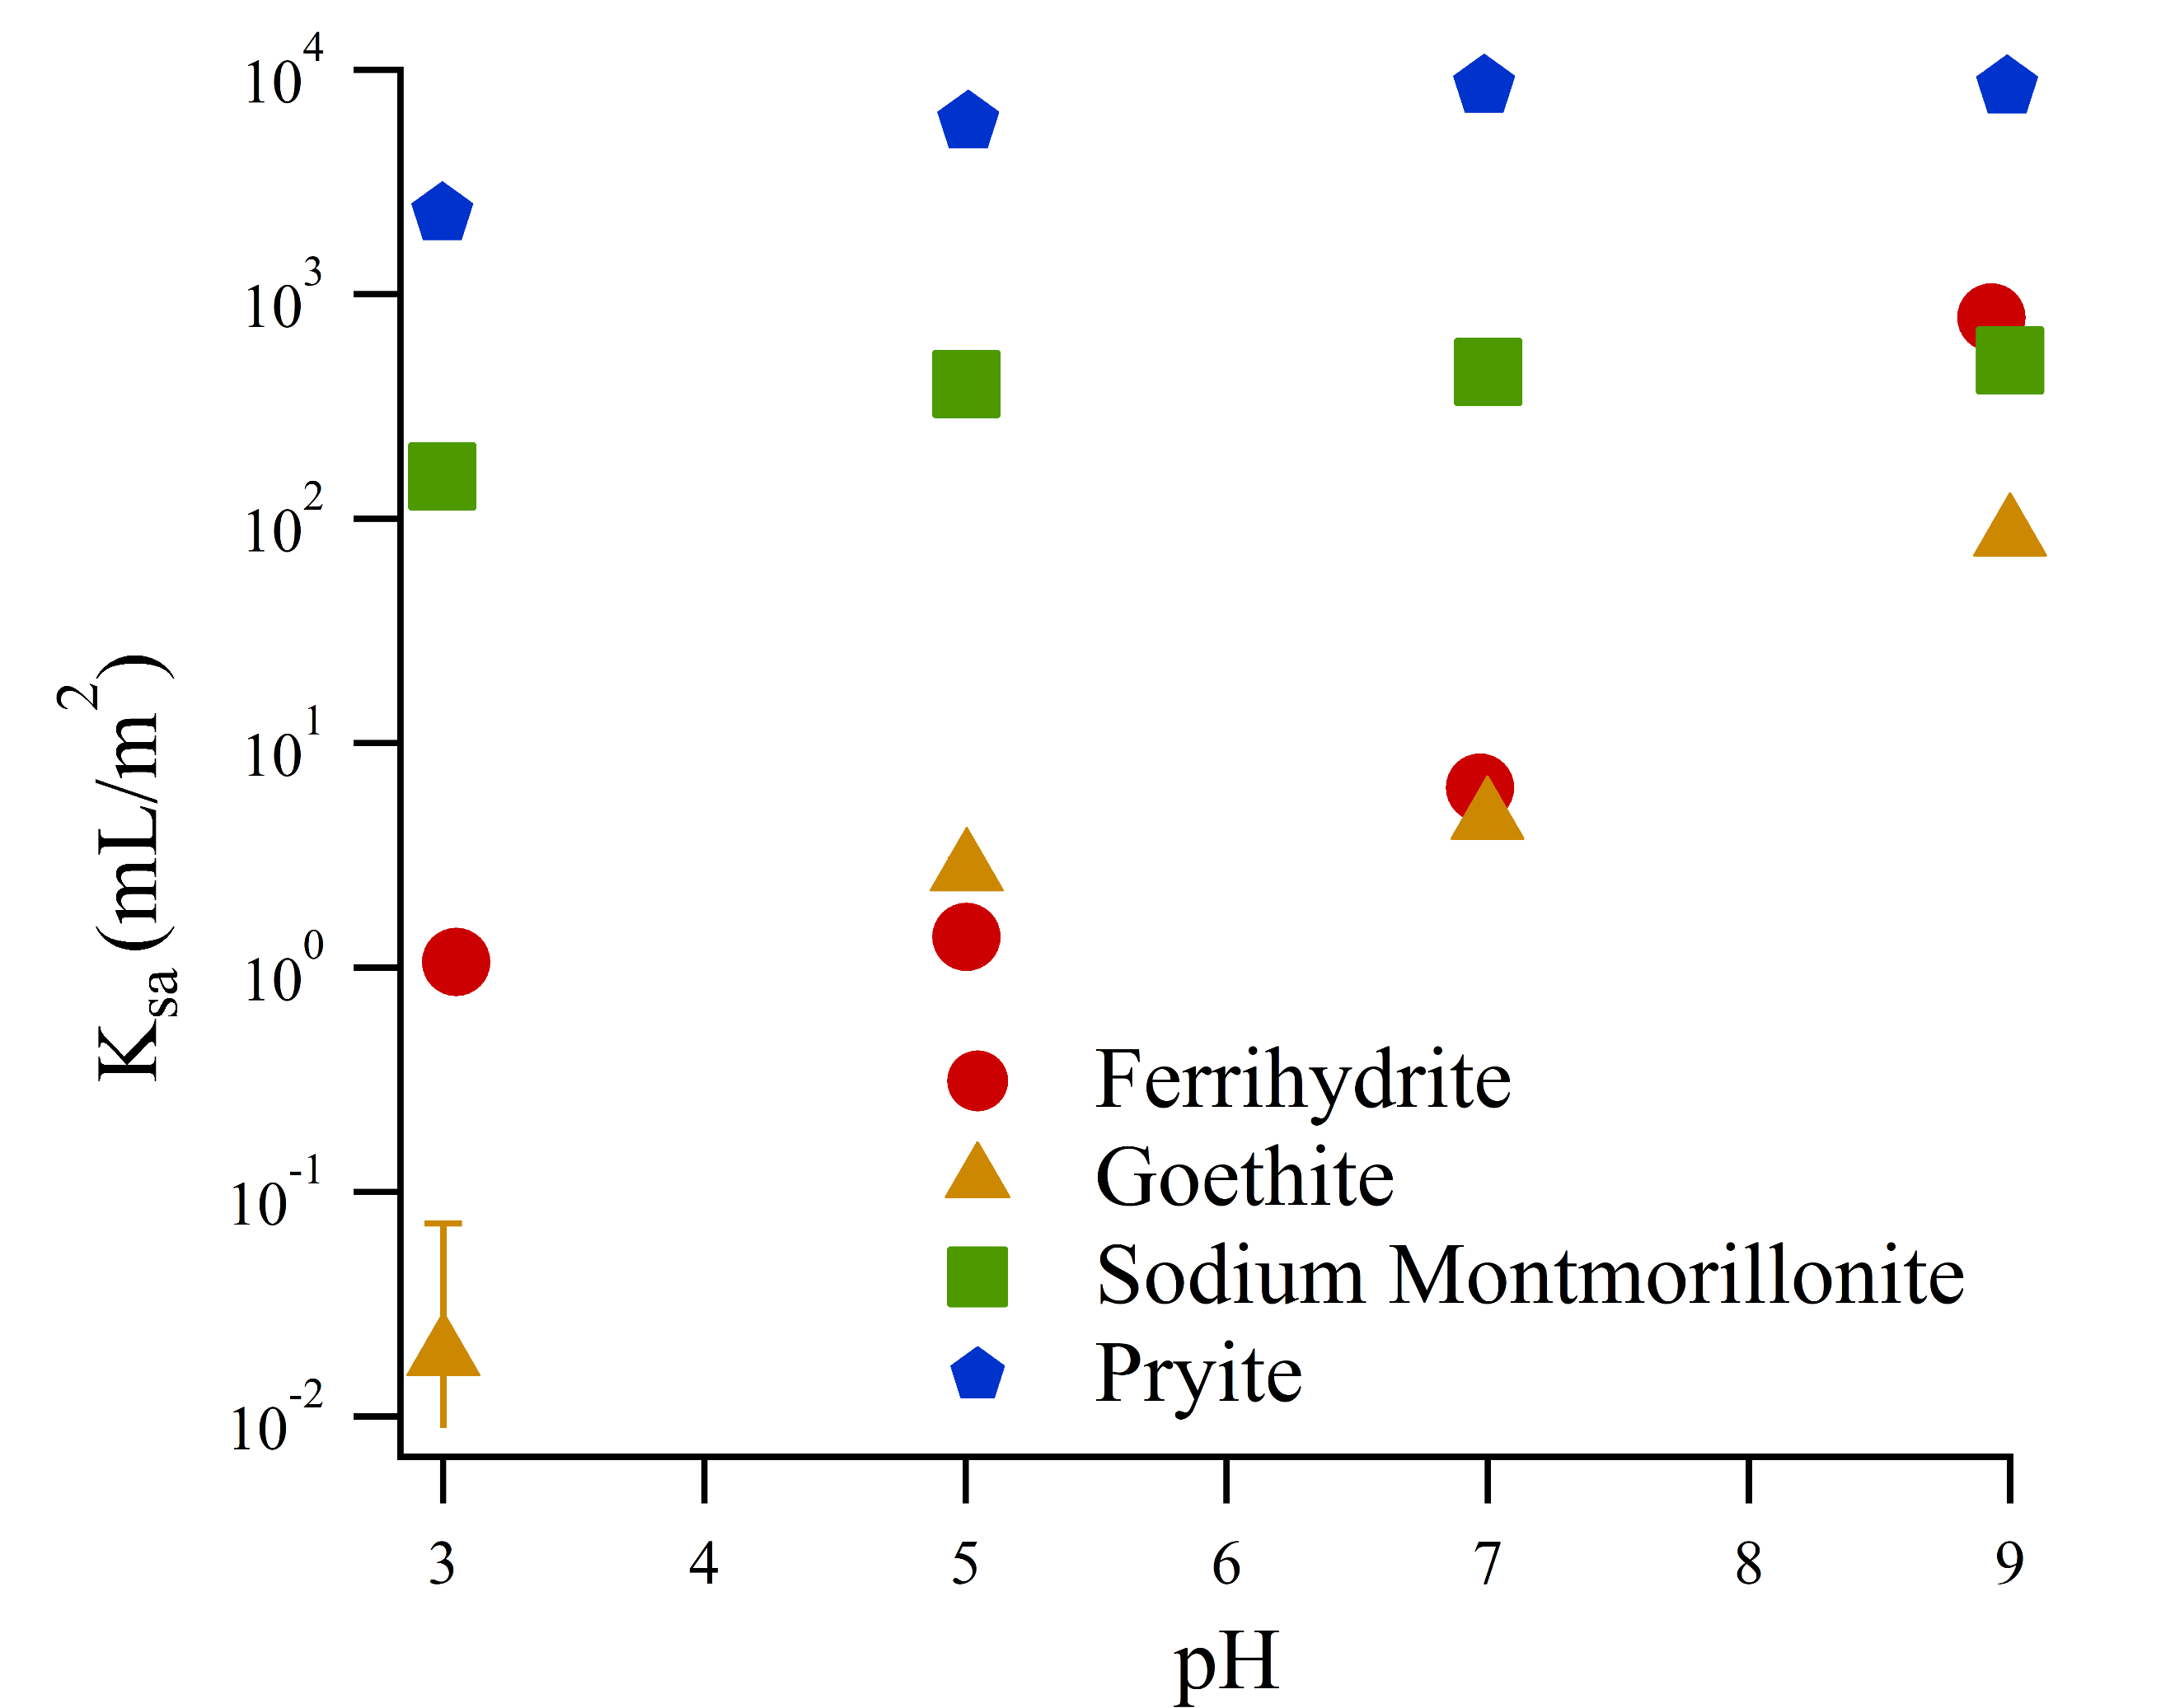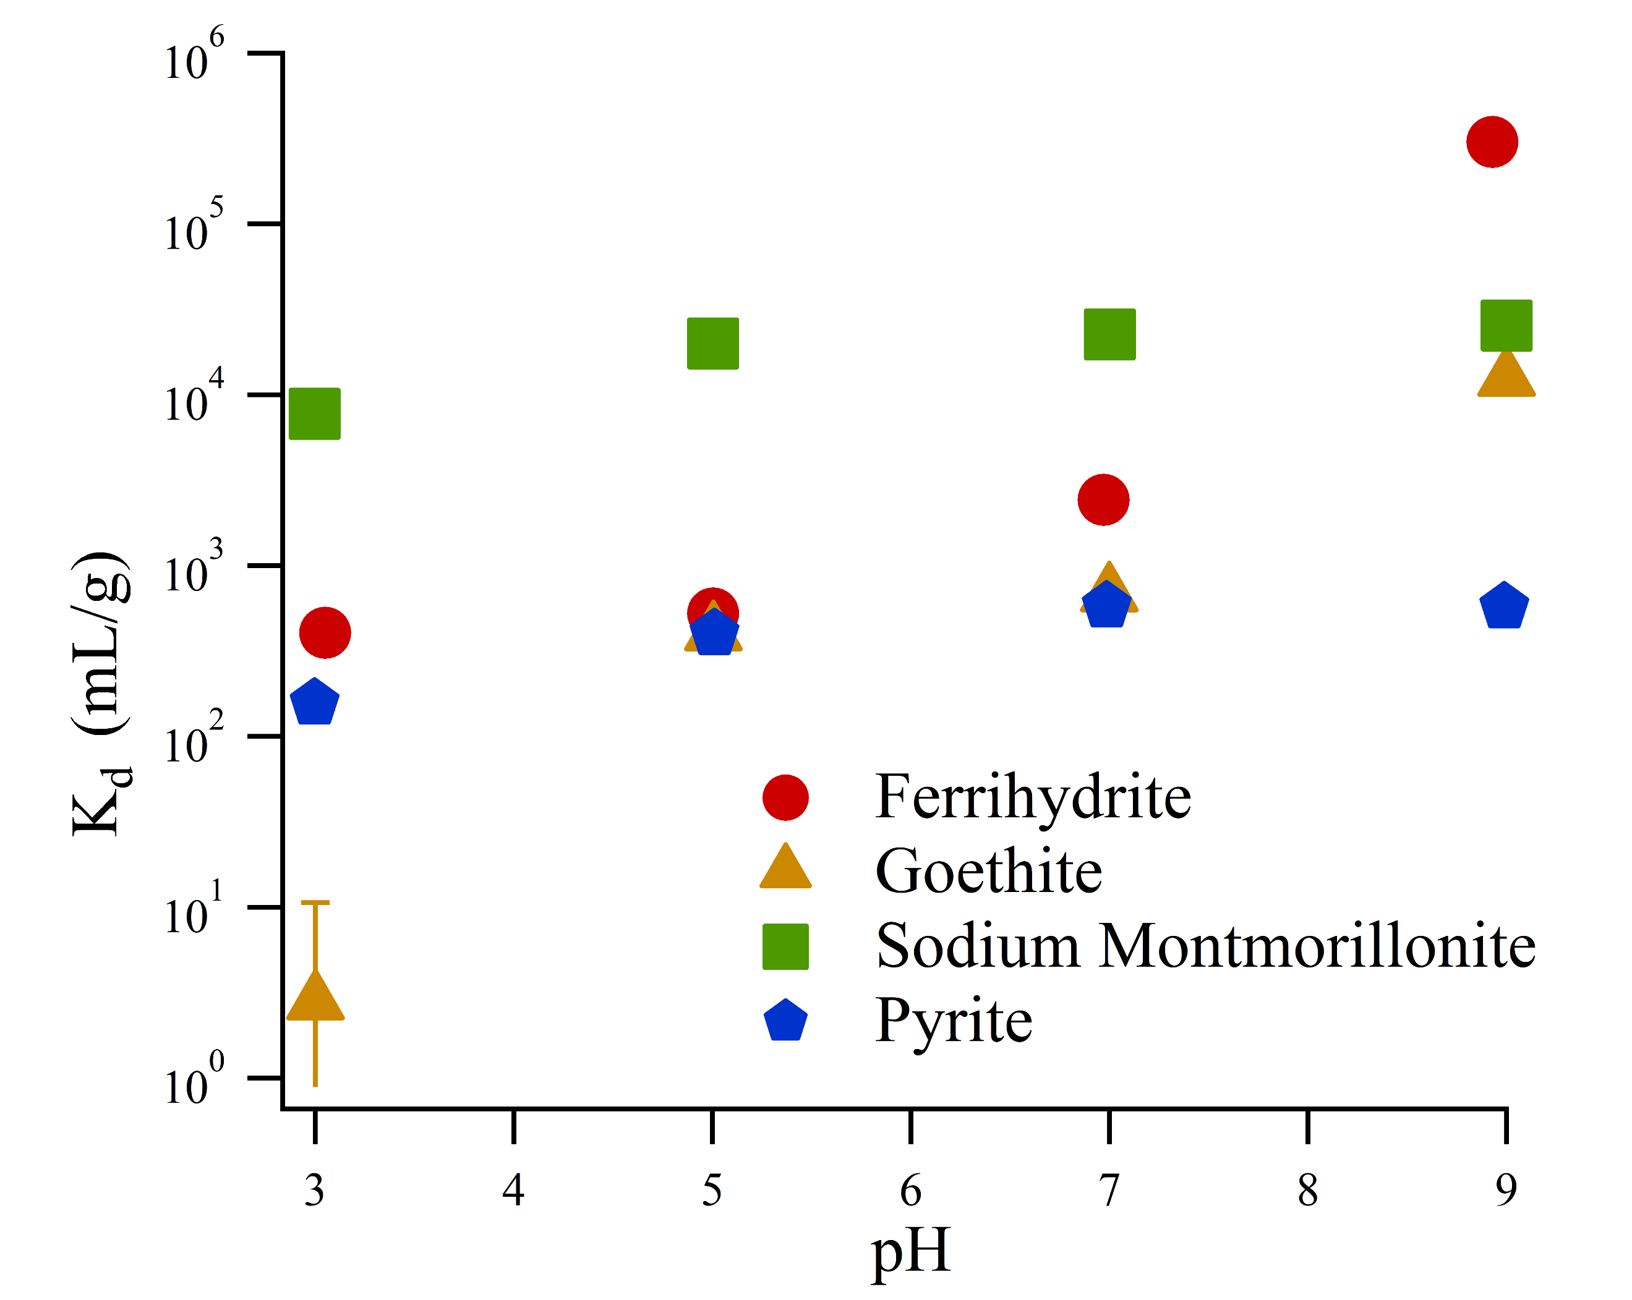

Figure 1: Sorption isotherm fits normalized by mass (left, figure 1a) or by surface area (right, figure 1b)

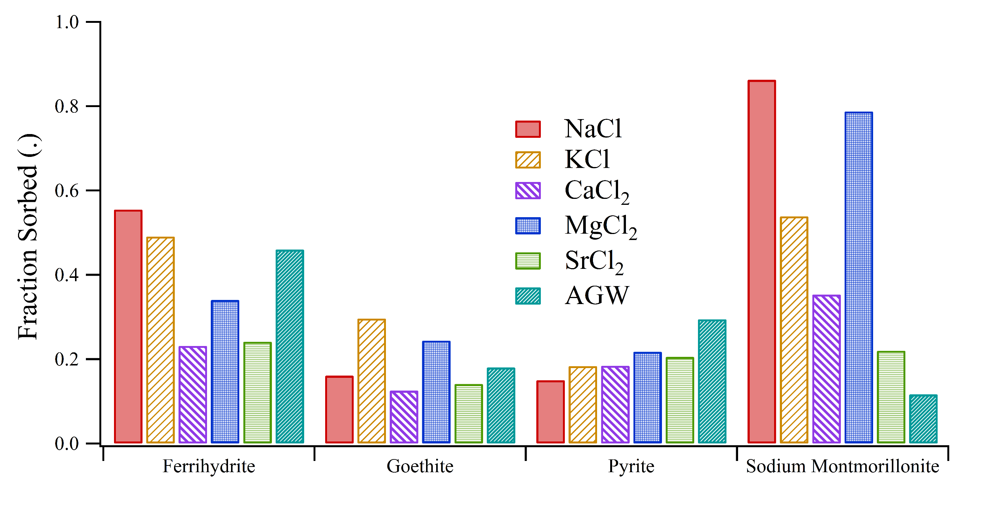

Figure 2: The impact of different competing cations on Ra sorption to different minerals, performed at similar ionic strength.

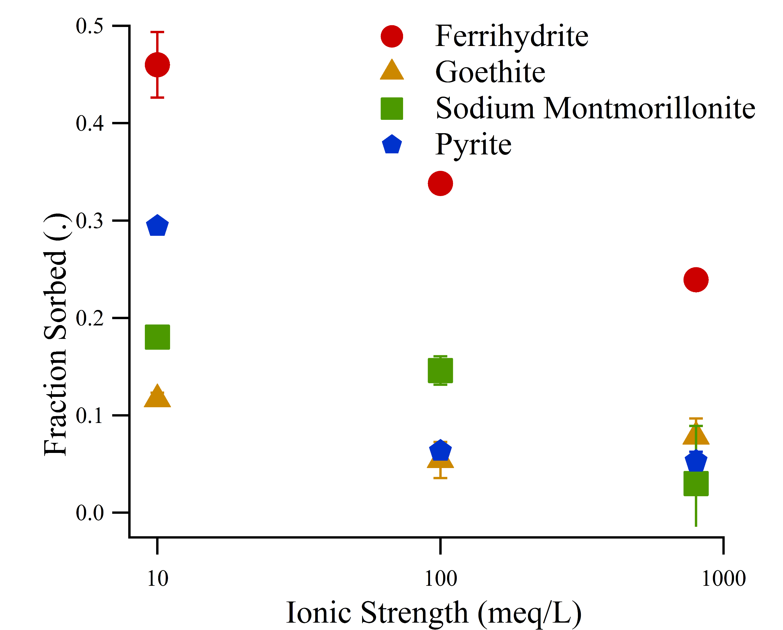Figure 3: The impact of increasing ionic strength mixed cation solutions on fractional sorption, performed at pH 7 for different mineral phases.

**Author Information**

**Corresponding Author:** Benjamin D. Kocar, 15 Vassar Street, Building 48-323. Department of Civil and Environmental Engineering, Massachusetts Institute of Technology, Cambridge, MA 02139. [kocar@mit.edu](mailto:kocar@mit.edu). 617-324-7746

**References**

(1) Zhang, T.; Gregory, K.; Hammack, R. W.; Vidic, R. D. Co-precipitation of radium with barium and strontium sulfate and its impact on the fate of radium during treatment of produced water from unconventional gas extraction. *Environ. Sci. Technol.* **2014**, *48* (8), 4596–4603 DOI: 10.1021/es405168b.

(2) Jones, A. P. Indoor air quality and health. *Atmos. Environ.* **1999**, *33* (28), 4535–4564 DOI: 10.1016/S1352-2310(99)00272-1.

(3) Lu, N.; Mason, C. F. V. Sorption-desorption behavior of strontium-85 onto montmorillonite and silica colloids. *Appl. Geochemistry* **2001**, *16* (14), 1653–1662 DOI: 10.1016/S0883-2927(01)00060-9.

(4) Szabo, Z.; dePaul, V. T.; Fischer, J. M.; Kraemer, T. F.; Jacobsen, E. Occurrence and geochemistry of radium in water from principal drinking-water aquifer systems of the United States. *Appl. Geochemistry* **2012**, *27* (3), 729–752 DOI: 10.1016/j.apgeochem.2011.11.002.

(5) Barbot, E.; Vidic, N. S. N.; Gregory, K. B. K. K. B.; Vidic, R. D. R. Spatial and temporal correlation of water quality parameters of produced waters from devonian-age shale following hydraulic fracturing. *Environ. Sci. Technol.* **2013**, *47* (6), 2562–2569 DOI: 10.1021/es304638h.

(6) Vengosh, A.; Hirschfeld, D.; Vinson, D.; Dwyer, G.; Raanan, H.; Rimawi, O.; Al-zoubi, A.; Akkawi, E.; Marie, A.; Haquin, G.; et al. High Naturally Occurring Radioactivity in Fossil Groundwater from the Middle East. *Environ. Sci. Technol.* **2009**, *43*, 1769–1775 DOI: 10.1021/es802969r.

(7) Lauer, N.; Vengosh, A. Age Dating Oil and Gas Wastewater Spills Using Radium Isotopes and Their Decay Products in Impacted Soil and Sediment. *Environ. Sci. Technol. Lett.* **2016**, *3* (5), acs.estlett.6b00118 DOI: 10.1021/acs.estlett.6b00118.

(8) Fesenko, S.; Carvalho, F.; Martin, P.; Moore, W. S.; Yankovich, T. Radium in the Environment. *The Environmental Behavior of Radium: Revised Edition*. 2014, pp 33–105.

(9) Gonneea, M. E.; Morris, P. J.; Dulaiova, H.; Charette, M. a. New perspectives on radium behavior within a subterranean estuary. *Mar. Chem.* **2008**, *109* (3–4), 250–267 DOI: 10.1016/j.marchem.2007.12.002.

(10) Grivé, M.; Duro, L.; Colàs, E.; Giffaut, E. Thermodynamic data selection applied to radionuclides and chemotoxic elements: An overview of the ThermoChimie-TDB. *Appl. Geochemistry* **2015**, *55*, 85–94 DOI: 10.1016/j.apgeochem.2014.12.017.

(11) Beck, A. J.; Cochran, M. a. Controls on solid-solution partitioning of radium in saturated marine sands. *Mar. Chem.* **2013**, *156*, 38–48 DOI: 10.1016/j.marchem.2013.01.008.

(12) Sajih, M.; Bryan, N. D. D.; Livens, F. R. R.; Vaughan, D. J. J.; Descostes, M.; Phrommavanh, V.; Nos, J.; Morris, K. Adsorption of radium and barium on goethite and ferrihydrite: A kinetic and surface complexation modelling study. *Geochim. Cosmochim. Acta* **2014**, *146*, 150–163 DOI: 10.1016/j.gca.2014.10.008.

(13) Sverjensky, D. A. Prediction of the speciation of alkaline earths adsorbed on mineral surfaces in salt solutions. *Geochim. Cosmochim. Acta* **2006**, *70* (10), 2427–2453 DOI: 10.1016/j.gca.2006.01.006.

(14) Schwertmann, U.; Cornell, R. *Iron Oxides in the Laboratary*; Wiley-VCH Verlag GmbH: Weinheim, Germany, 2000.

(15) Tamamura, S.; Takada, T.; Tomita, J.; Nagao, S.; Fukushi, K.; Yamamoto, M. Salinity dependence of 226Ra adsorption on montmorillonite and kaolinite. *J. Radioanal. Nucl. Chem.* **2013**, *299* (1), 569–575 DOI: 10.1007/s10967-013-2740-3.

(16) Parkhurst, D. L.; Appela, C. A. J. *Description of Input and Examples for PHREEQC Version 3 — A Computer Program for Speciation , Batch-Reaction , One-Dimensional Transport , and Inverse Geochemical Calculations*; 2013.

(17) Dzombak, D.; Morel, F. *Surface Complexation Modeling: Hydrous Ferric Oxide*; Wiley: New York, NY, 1990.

(18) Mathur, S. S.; Dzombak, D. A. Surface complexation modeling: Goethite; 2006; pp 443–468.

(19) Bradbury, M. H.; Baeyens, B. A mechanistic description of Ni and Zn sorption on Part II: modelling. *J. Contam. Hydrol.* **1997**, *27*, 223–248 DOI: 10.1016/S0169-7722(97)00008-9.

(20) Ames, L.; McGarrah, J.; Walker, B. Sorption of trace constituents from aqueous solutions onto secondary minerals. II. Radium. *Clays Clay Miner.* **1983**, *31* (5), 335–342.

(21) Ames, L. L. Sorption of Trace Constituents from Aqueous Solutions onto Secondary Minerals. I. Uranium. *Clays Clay Miner.* **1983**, *31* (5), 321–334 DOI: 10.1346/CCMN.1983.0310501.

(22) Naveau, A.; Monteil-Rivera, F.; Dumonceau, J.; Catalette, H.; Simoni, E. Sorption of Sr(II) and Eu(III) onto pyrite under different redox potential conditions. *J. Colloid Interface Sci.* **2006**, *293* (1), 27–35 DOI: 10.1016/j.jcis.2005.06.049.

(23) Murphy, R.; Strongin, D. Surface reactivity of pyrite and related sulfides. *Surf. Sci. Rep.* **2009**, *64* (1), 1–45 DOI: 10.1016/j.surfrep.2008.09.002.

(24) Kornicker, W. A.; Morse, J. W. Interactions of divalent cations with the surface of pyrite. *Geochim. Cosmochim. Acta* **1991**, *55* (8), 2159–2171 DOI: 10.1016/0016-7037(91)90094-L.

(25) Wersin, P.; Hochella, M. F.; Persson, P.; Redden, G.; Leckie, J. O.; Harris, D. W. Interaction between aqueous uranium (VI) and sulfide minerals: Spectroscopic evidence for sorption and reduction. *Geochim. Cosmochim. Acta* **1994**, *58* (13), 2829–2843 DOI: 10.1016/0016-7037(94)90117-1.

(26) Naveau, A.; Monteil-Rivera, F.; Guillon, E.; Dumonceau, J. Interactions of aqueous selenium (-II) and (IV) with metallic sulfide surfaces. *Environ. Sci. Technol.* **2007**, *41* (15), 5376–5382 DOI: 10.1021/es0704481.

(27) Das, D. K.; Pathak, P. N.; Kumar, S.; Manchanda, V. K. Sorption behavior of Am3+ on suspended pyrite. *J. Radioanal. Nucl. Chem.* **2009**, *281* (3), 449–455 DOI: 10.1007/s10967-009-0030-x.

(28) Bradbury, M. H.; Baeyens, B. A mechanistic description of Ni and Zn sorption on Na-montmorillonite Part II: modelling. *J. Contam. Hydrol.* **1997**, *27* (3–4), 223–248 DOI: 10.1016/S0169-7722(97)00007-7.

(29) Bradbury, M. H.; Baeyens, B.; Geckeis, H.; Rabung, T. Sorption of Eu(III)/Cm(III) on Ca-montmorillonite and Na-illite. Part 2: Surface complexation modelling. *Geochim. Cosmochim. Acta* **2005**, *69* (23), 5403–5412 DOI: 10.1016/j.gca.2005.06.031.